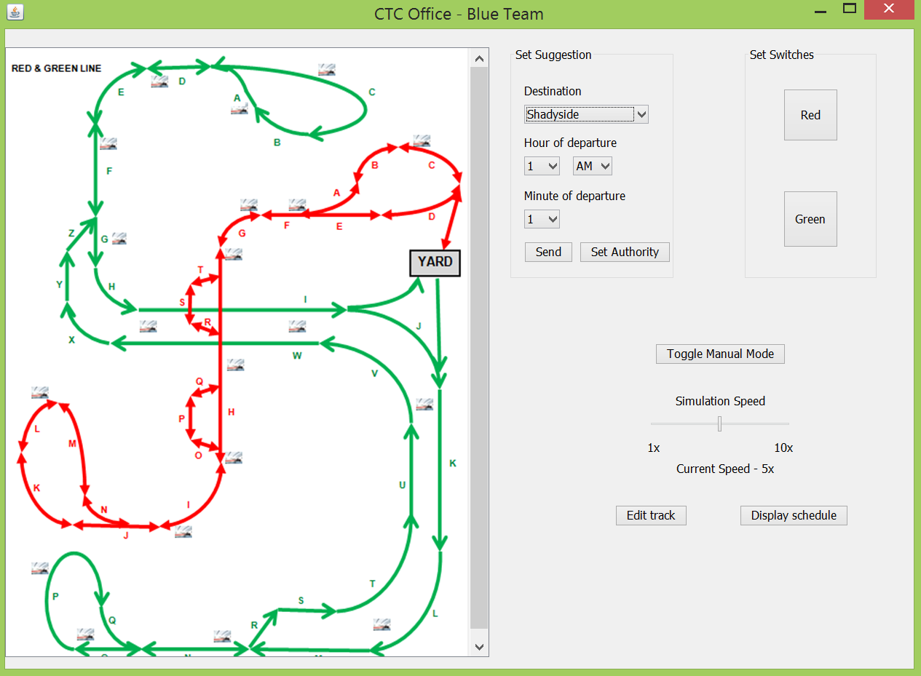User Manual for CTC Office- Ritesh Misra, Blue Team

32

22

1

Section 1: This section allows you to select the parameters for sending a suggestion to a wayside controller and then allows you to send the suggestion. First, you must click on the dropdown menu to specify the destination. You should then see this:

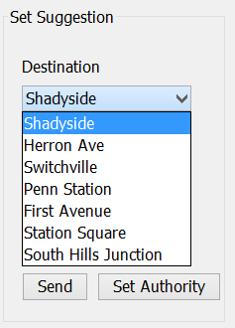

Whichever destination you select is the one that the train will be sent to. Shadyside is selected as the default for no particular reason. You can then access very similar dropdown menus to select the time. For the “Hour of Departure,” you will be able to select a number from 1 to 12 and then AM or PM in order to specify the hour that the train must leave. You may then select the minute that the train should leave by dropping down the “Minute of departure” menu and selecting a number from 1 to 59. Lastly, 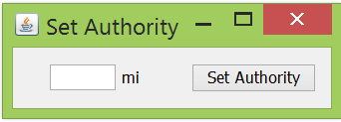you must click the “Set Authority” button to bring up this window.

You may now enter whatever authority you wish for the train to follow.

Lastly, you will only be allowed to click the send button once you have specified the authority. If you do not specify any of the other variables, the wayside controller will receive the suggestion that it send a train to Shadyside starting at 1:01 AM because of the default values of the entries. It is up to the dispatcher to not make this simple mistake.

Section 2:

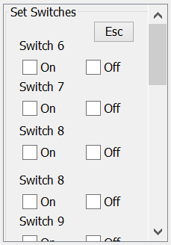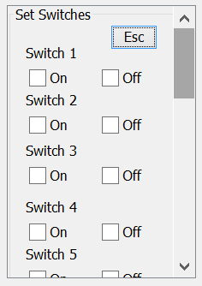This section allows you to set the switches on the track. You must first select the line you want to set switches for by clicking either “Red” or “Green”. Depending on which one you select, a different window will show up and allow you to set the corresponding switches.

The Red Line switches

The Green Line switches

The Green Line switches

After you have modified the switches to your ideal configuration, you may then press the “Esc” button to return to the main CTC GUI.

Section 3:

First of all, you have the option to toggle manual mode. The CTC office starts off in automatic mode (i.e. everything is automated except for sending suggestions to the wayside controller). If you wish to take direct control over the CTC, you may click the button labeled “Toggle Manual Mode,” and it will become blue, indicating that you now have control over the CTC.

Below that is a slider to change the simulation speed. Drag the slider around and leave it in a position to update the current value of the simulation speed, which will be updated right under the slider next to “Current Speed”.

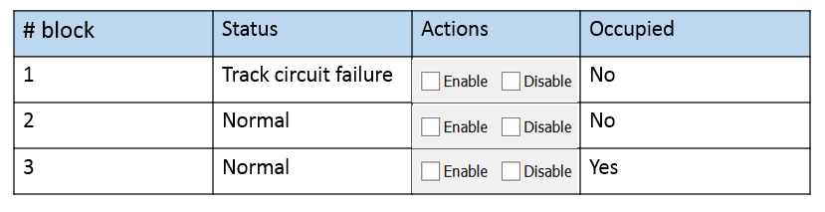If you click “Edit Track,” you will bring up this table:

You will be allowed to scroll through all of the blocks and check their status and whether they are occupied or not. You will also be able to enable or disable blocks manually by clicking the corresponding check box. In automatic mode, blocks are disabled as the wayside controller reports block failures.

If you click “Display Schedule,” you will bring up this table.

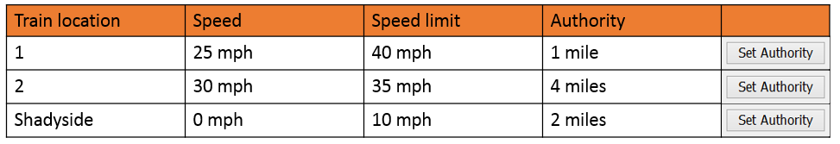

On the left is either the block number or a station where a train is currently located. The second column is the speed of the train, the third column shows the fastest speed the train is allowed to go, and the last column displays the authority of the train. Lastly, the dispatcher has the option to change the authority of the train as they wish. Clicking the “Set Authority” button brings up the same window displayed earlier in Section 1 of the User Manual.